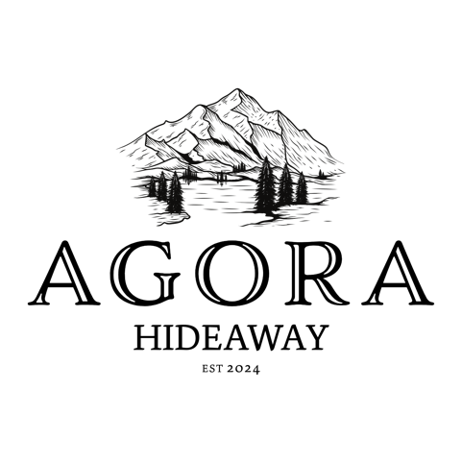

**Contents**

Development Application for Temporary Recreational Camping Events 3

Event Overview 3

Facilities and Services 3

Emergency Procedures 3

Event Management 4

Community and Environmental Considerations 4

Conclusion 4

Proposed Events for 2025 5

Proposed Event #1 Big Oz Camp Out 5

Proposed Event #2 American Truck and Van Jamboree 6

Proposed Event #3 Big Oz Camp Out 7

Proposed Event #4 To Be Advised 8

Statement of Environmental Effects for Agora Hideaway 9

Environmental Impacts of the Development 9

Identification of Environmental Impacts 9

Mitigation Measures 9

Compliance with Planning Policies and Controls 10

Contextual Considerations 10

Supporting Visuals 10

Conclusion 14

Agora Hideaway Flood Management Plan 15

Objective 15

Site Description 15

Pre-Arrival Communication 15

On-Site Monitoring and Notifications 15

Flood Risk Response 15

Continuous Updates 15

Review and Update 15

Agora Hideaway Bushfire Evacuation Plan 16

Objective 16

Site Description 16

Bushfire Risk Assessment 16

Emergency Contacts 16

Evacuation Triggers 16

Evacuation Procedures 16

Evacuation Route 16

Evacuation Assembly Point: 17

Special Considerations: 17

Communication Plan 17

First Aid and Medical Support 17

Post-Evacuation Procedures 17

Bushfire Safety Measures 17

Review and Update 17

Appendix A 18

# Development Application for Temporary Recreational Camping Events

## Event Overview

**Event Type:** Recreational camping event

**Event Duration:** 2-3 night durations. Typically held on long weekends, over Friday and Saturday nights

**Frequency:** Approximately once per quarter (4 times annually)

**Maximum Capacity:** 200 people (including up to 100 caravans)

**Participants:** Recreational users of caravans, campers, and/or tents/swags

**Location:** Agora Hideaway, Mole River NSW

## Facilities and Services

**Toilet Facilities**

Toilets will be brought in on a hire basis for the duration of each event.

Regular maintenance will be conducted to ensure cleanliness and hygiene.

**Costing**

Quotes have been obtained from local suppliers averaging approximately $300 per toilet including pump out clean and delivery fees. It is recommended for 1 toilet per 15 attendees.

**First Aid**

A commercial first aid kit will be available on-site.The business owner is a trained EN nurse and certified first aid officer and will be present during the entirety of the event.Signage will be mounted detailing evacuation procedures, emergency contacts, and the location of first aid kits.

## Emergency Procedures

**Fire/Flood Procedures**

Evacuation plans will be clearly communicated to all participants in emailed booking documents.

Signage with an evacuation route, assembly point and UHF details will be prominently displayed.

RFS Mapping data will be utilized for accurate location services in case of emergencies.

Satellite internet will be in use allowing WIFI calling if help is needed.

Channel 48 is the UHF repeater channel for the Mingoola area and channel 19 is the UHF channel Agora Hideaway uses.

**Emergency Contacts**

Contact information for local emergency services will be provided on signage and to key representatives/staff who are hosting/working an event.Designated personnel responsible for coordinating emergency responses will be on-site.

**Waste Management**

Bins will be provided for domestic waste throughout the event area with additional skip bins/trailer brought in to account for additional waste requirements. Waste will be collected and disposed of by Agora Hideaway at the end of each event. Efforts will be made to minimize waste and encourage recycling where possible. Agora Hideaway staff will meticulously clean the camping area after an event in an effort to leave no human traces.

**Costing**

Hire skip bin from Tenterfield Shire Council OR use a large high wall trailer and dump at local dump. Up to $300 per load/bin.

## Event Management

**Event Coordination**

Agora Hideaway owners will oversee the planning and execution of each event. Regular communication with local authorities and emergency services will be undertaken to ensure compliance with safety regulations and so that knowledge of the event is common should there be an emergency situation arise.

**Guest Management**

Bookings will be required for all participants to manage numbers and ensure adherence to capacity limits. Check in and check out times will apply. Clear guidelines will be provided to participants regarding the use of facilities, waste disposal, and emergency procedures before arrival.

## Community and Environmental Considerations

**Community Impact**

Efforts will be made to minimize disruption to the local community. Noise levels will be monitored and controlled with quiet time instated between 10pm and 7am. Generators will be allowed to be run between 7am and 7pm daily.

**Environmental Impact**

Measures will be taken to protect the natural environment of the site, including waste management and respecting wildlife habitats. Guests will be asked to stay on designated tracks and not to disturb fauna and flora in the area. Fishing is strictly prohibited and will be monitored.

## Conclusion

Agora Hideaway is committed to providing a safe, enjoyable, and environmentally responsible experience for all participants. We will adhere to all necessary regulations and work closely with local authorities to ensure the success of each event.

# Proposed Events for 2025

## Proposed Event #1 Big Oz Camp Out

**Event Overview**

**Event Date:** 6th – 9th March 2024

**Maximum Capacity:** 100 people (including up to 50 caravans)

**Participants:** Recreational users of caravans, campers, and/or tents/swags. Big Oz Explorers Community Members.

**Location:** Agora Hideaway, Mole River NSW

**Proposed Agenda:**

THURSDAY 6TH MARCH

Check in from 8:30am

ALL DAY: Lawn games for the kids & adults

ALL DAY: Scan QR Codes around the camp for a chance to WIN giveaways on Saturday afternoon. All winners will be announced between 4:00 – 8:00pm during live music event.

5:00pm: Happy hour at the communal fire.

FRIDAY 7th MARCH

ALL DAY: Lawn games for the kids & adults

ALL DAY: Scan QR Codes around the camp for a chance to WIN giveaways on Saturday afternoon. All winners will be announced between 4:00 – 8:00pm during live music event.

11:30am sharp: Leave camp in convoy to a local lunch venue. Possibly a Winery or Pub within 1 hour of Agora Hideaway Campground. Convoy will travel on UHF Channel 19.

11:45am-2:30pm: Lunch at chosen location.

2:30pm: Convoy back to camp with a convoy drone shot on arrival to Agora Hideaway.

4:00pm – 8:00pm Live music and a communal fire.

6:30pm: Movie Time. We will set up a portable screen and movie for children.

SATURDAY 8th MARCH

ALL DAY: Lawn games for the kids & adults

ALL DAY: Scan QR Codes around the camp for a chance to WIN giveaways on Saturday afternoon. All winners will be announced between 4:00 – 8:00pm during live music event.

10:30 – 11:30am Nature-based treasure hunt children attending. Run by Sian (First aid trained and Working with children check)

2:30pm – 3:30pm Trivia Afternoon. Prizes to be won!

3:45pm Group photo around 3:45pm before the music gets going.

4:00pm – 8:00pm Live music and a communal fire. Speeches and giveaways with Sian & Chris.

6:30pm: Movie Time. We will set up a portable screen and movie for children.

SUNDAY 9th MARCH

Check out by 12:00 noon.

## Proposed Event #2 American Truck and Van Jamboree

**Event Overview**

**Event Date:** 2nd – 5th May 2025

**Maximum Capacity:** 200 people (including up to 100 caravans)

**Participants:** Recreational users of caravans, campers with American vehicles.

**Location:** Agora Hideaway, Mole River NSW

**Proposed Agenda:**

The American Truck and Van Jamboree is the direct offspring from a successful 2024 event, The Ram Van Jamboree. There will be three days of bands, competitions, exhibitors and lots of fun. It's not just about the trucks but about getting out with our campers and caravans to enjoy the company of like minded folk.

FRIDAY 2nd MAY

Check in from 10:00am

Live Music - 7pm till 10pm

SATURDAY 3rd MAY

Live Music - 3pm - 6pm

Live Music - 7pm till 10pm

SUNDAY 4th MAY

Live Music - 7pm till 10pm

MONDAY 5th MAY

Check out by 12:00 noon

## Proposed Event #3 Big Oz Camp Out

**Event Overview**

**Event Date:** 18th – 21st September 2025

**Maximum Capacity:** 100 people (including up to 50 caravans)

**Participants:** Recreational users of caravans, campers, and/or tents/swags. Big Oz Explorers Community Members.

**Location:** Agora Hideaway, Mole River NSW

**Proposed Agenda:**

THURSDAY 18th SEPTEMBER

Check in from 8:30am

ALL DAY: Lawn games for the kids & adults

ALL DAY: Scan QR Codes around the camp for a chance to WIN giveaways on Saturday afternoon. All winners will be announced between 4:00 – 8:00pm during live music event.

5:00pm: Happy hour at the communal fire.

FRIDAY 19th SEPTEMBER

ALL DAY: Lawn games for the kids & adults

ALL DAY: Scan QR Codes around the camp for a chance to WIN giveaways on Saturday afternoon. All winners will be announced between 4:00 – 8:00pm during live music event.

11:30am sharp: Leave camp in convoy to a local lunch venue. Possibly a Winery or Pub within 1 hour of Agora Hideaway Campground. Convoy will travel on UHF Channel 19.

11:45am-2:30pm: Lunch at chosen location.

2:30pm: Convoy back to camp with a convoy drone shot on arrival to Agora Hideaway.

4:00pm – 8:00pm Live music and a communal fire.

6:30pm: Movie Time. We will set up a portable screen and movie for children.

SATURDAY 20th SEPTEMBER

ALL DAY: Lawn games for the kids & adults

ALL DAY: Scan QR Codes around the camp for a chance to WIN giveaways on Saturday afternoon. All winners will be announced between 4:00 – 8:00pm during live music event.

10:30 – 11:30am Nature-based treasure hunt children attending. Run by Sian (First aid trained and Working with children check)

2:30pm – 3:30pm Trivia Afternoon. Prizes to be won!

3:45pm Group photo around 3:45pm before the music gets going.

4:00pm – 8:00pm Live music and a communal fire. Speeches and giveaways with Sian & Chris.

6:30pm: Movie Time. We will set up a portable screen and movie for children.

SUNDAY 21st SEPTEMBER

Check out by 12:00 noon.

## Proposed Event #4 To Be Advised

**Event Overview**

**Event Date:** 13th – 16th November 2025

**Maximum Capacity:** 100 people (including up to 50 caravans)

**Participants:** Recreational users of caravans, campers, and/or tents/swags.

**Location:** Agora Hideaway, Mole River NSW  
  
**Proposed Agenda:**

This is the proposed date for an event. The event details have not been finalised. Relevant parties would be advised when this date is booked for an event by a third party.

# Statement of Environmental Effects for Agora Hideaway

**Project Overview**

Agora Hideaway proposes to host recreational camping events on a quarterly basis. These events will accommodate up to 200 participants, including up to 100 caravans, on the property located at Mole River, NSW.

**Purpose of the Statement**

This Statement of Environmental Effects (SEE) outlines the environmental impacts of the proposed development and the measures that will be implemented to mitigate these impacts. It also addresses compliance with relevant planning policies and controls.

## Environmental Impacts of the Development

**Site Disturbance**

**During Development:** Minimal site disturbance is anticipated, as the events will use existing cleared areas for camping. Any necessary ground preparation will be limited to temporary setups and will not involve significant earthworks.

**After Development:** The site will be restored to its natural state following each event, with no permanent structures or alterations.

**Waste Management**

Bins for domestic waste will be provided and regularly serviced during events. All waste will be disposed of responsibly by Agora Hideaway after each event, ensuring minimal impact on the environment.

**Noise Pollution**

Noise levels will be controlled to comply with local regulations, and events will be held at a distance from neighbouring properties to minimise disturbance with quiet time instated between 10pm and 7am and generators only being allowed to be run between 7am and 7pm daily.

**Traffic and Access**

Traffic and caravan site management will be implemented to ensure safe and controlled access with sufficient space between campers, cars and caravan sites. Volunteers and/or signage will be utilised to direct participants, reducing the likelihood of congestion or impact on local roads.

## Identification of Environmental Impacts

**Methods Used**

Site inspection with council has been conducted to identify potential environmental impacts. Analysis of similar events in comparable settings held by sister company “Big Oz Explorers” has provided insights into possible impacts and effective mitigation strategies.

## Mitigation Measures

**Site Management**

Temporary facilities, such as toilets and waste bins, will be carefully managed to minimise environmental impact. They will be positioned appropriately to avoid disturbance to waterways. After each event, the site will be thoroughly cleaned and inspected.

**Emergency Preparedness**

Evacuation plans and emergency procedures will be in place to address potential risks, such as fire or flood. RFS Mapping data will be utilised for precise location tracking and emergency response.

**Noise Control**

Sound levels will be monitored, and event programming will be designed to limit noise during sensitive hours.

**Waste Reduction**

Recycling initiatives will be promoted among participants, and all waste will be appropriately sorted and disposed of at the end of the event by Agora Hideaway.

## Compliance with Planning Policies and Controls

**Zoning and Land Use**

The proposed development is consistent with the current zoning regulations and land use policies for Temporary Use of Land under Clause 2.8 of *Tenterfield Local Environmental Plan 2013*.

**Building Height and Setbacks**

As the development does not involve permanent structures, there are no implications for building height, setbacks, or building envelope controls.

**Landscape and Aesthetic Considerations**

The natural landscape will be preserved, and any temporary structures will be designed to blend with the surrounding environment. No permanent changes to the landscape are proposed.

## Contextual Considerations

**Surrounding Development**

The site is located in a rural setting with minimal surrounding development. The proposed events are in harmony with the character of the area.

**Future Development Context**

There is no anticipated significant change in the surrounding built form. The proposed events will continue to align with the rural nature of the area.

## Supporting Visuals

**Drawings and/or Plans**

Drawings of the site layout, including the placement of temporary facilities (orange) and camping areas, are included below.

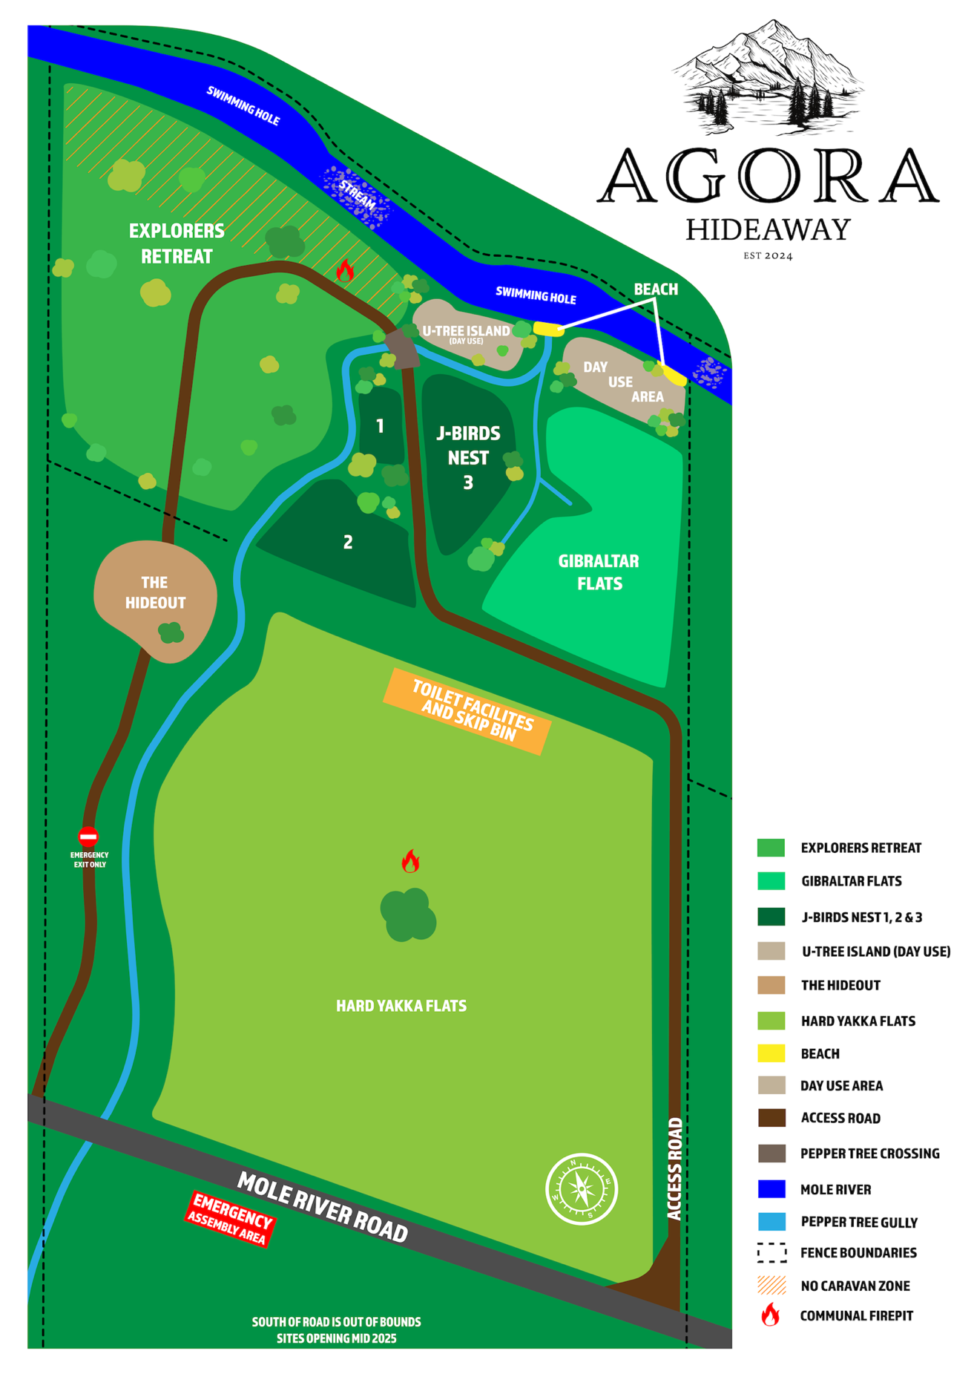

**Imagery**

Photos have been provided to illustrate the temporary event setup in the context of the surrounding environment. These are examples from previous events held by Big Oz Explorers, the sister company to Agora Hideaway at similar campsites across Australia.

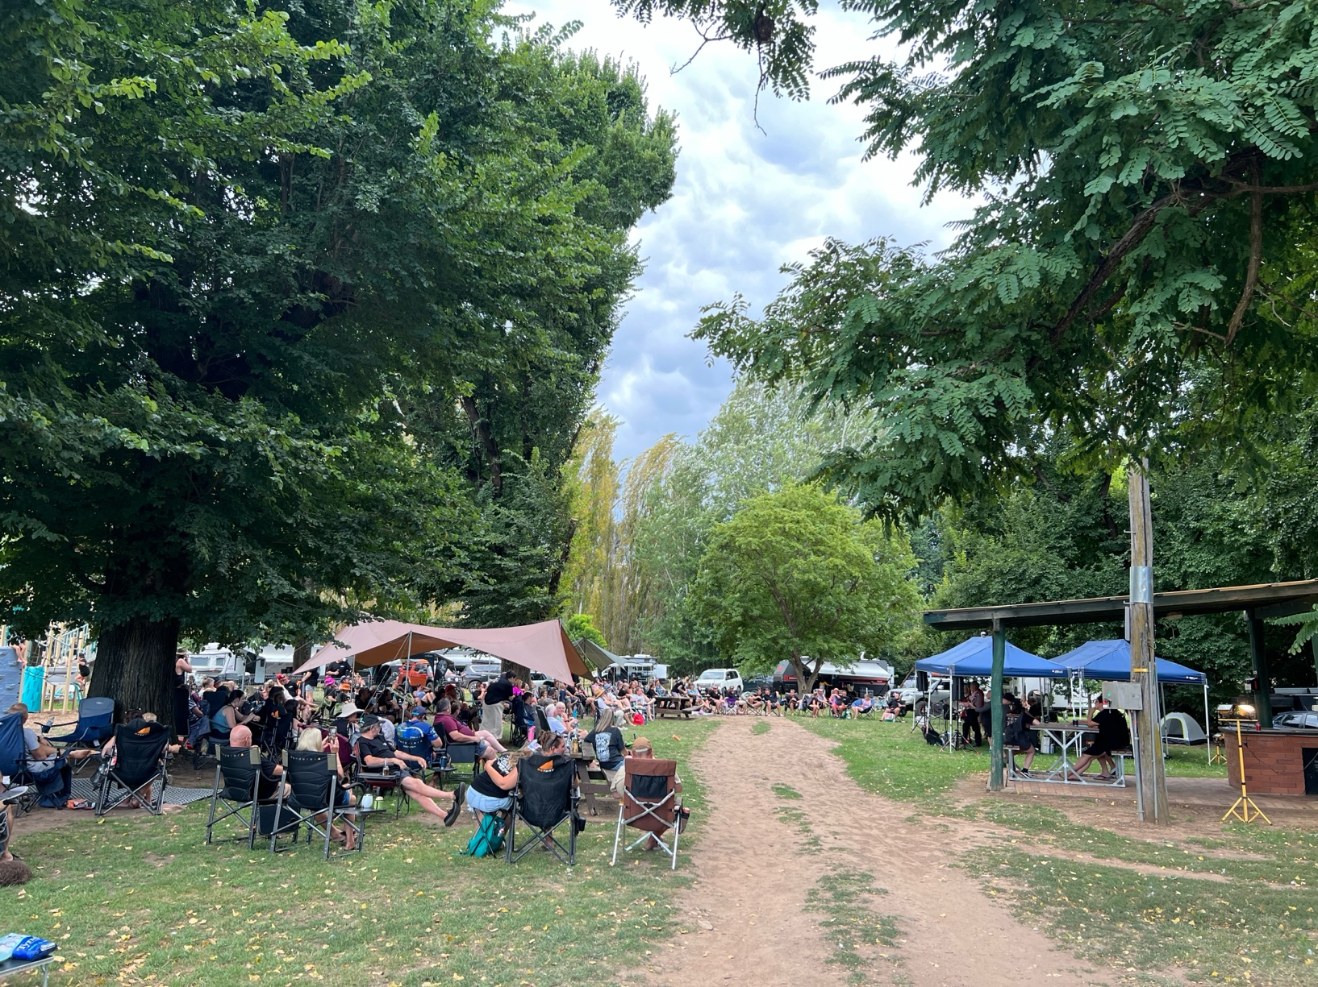

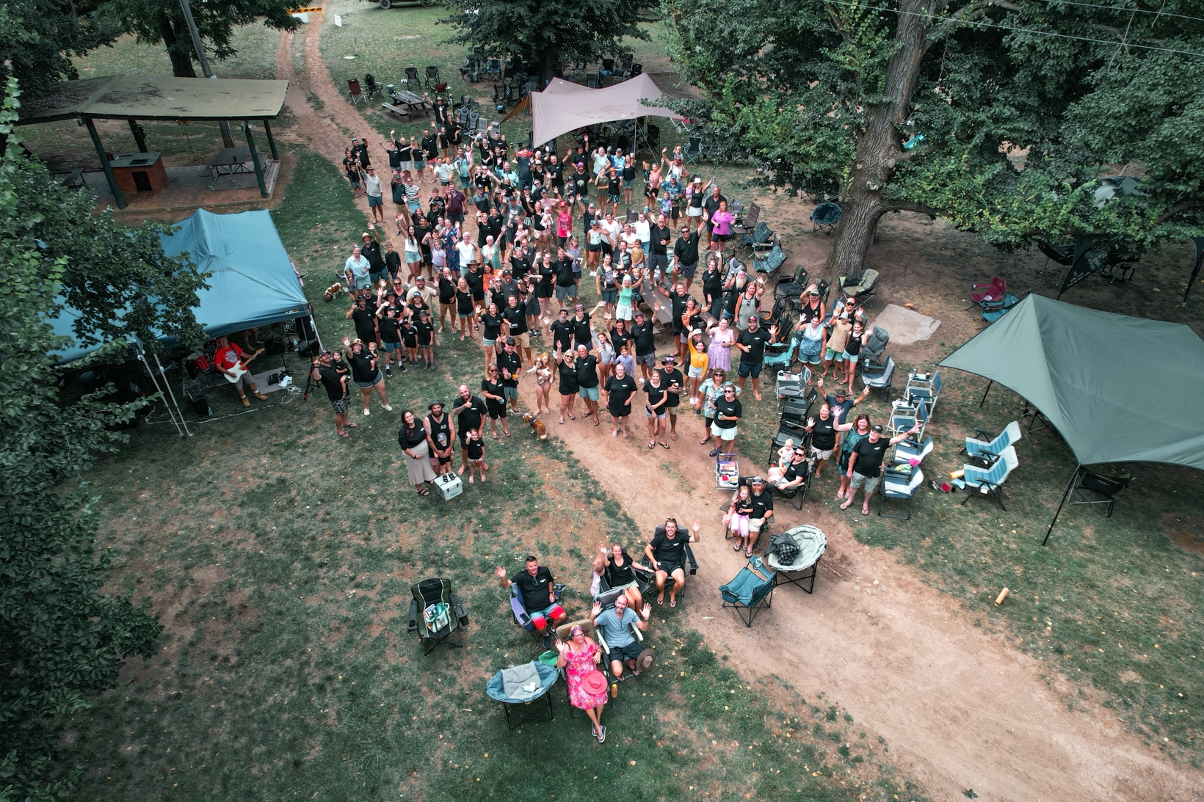

Billy Grace Reserve, Wee Jasper, NSW. 204 people attended this event with 98 caravans.

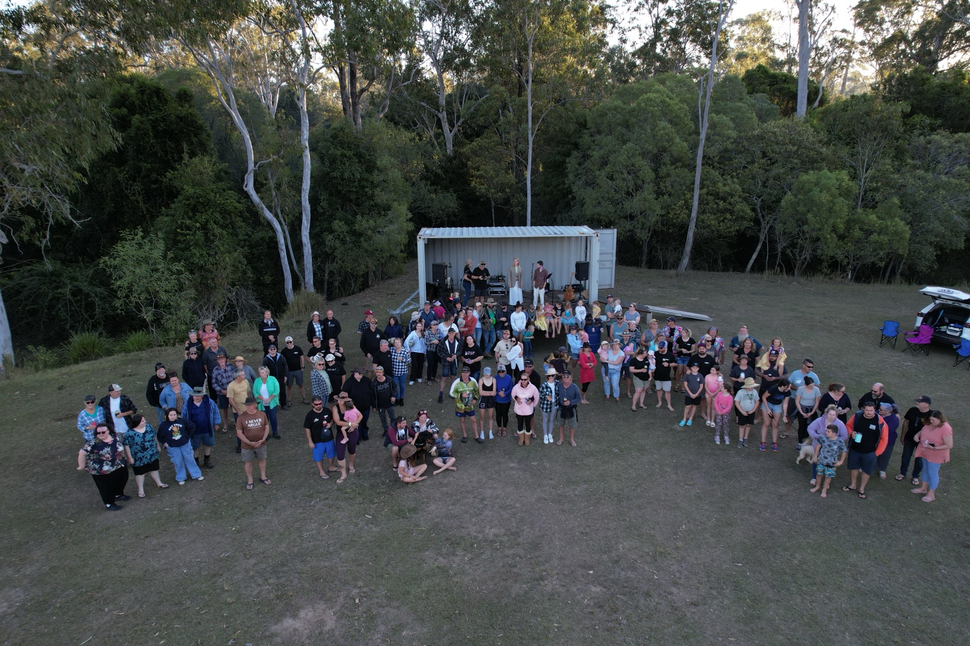

Gootchie Creek Escape, Gootchie, QLD. 163 people attended this event with 64 caravans.

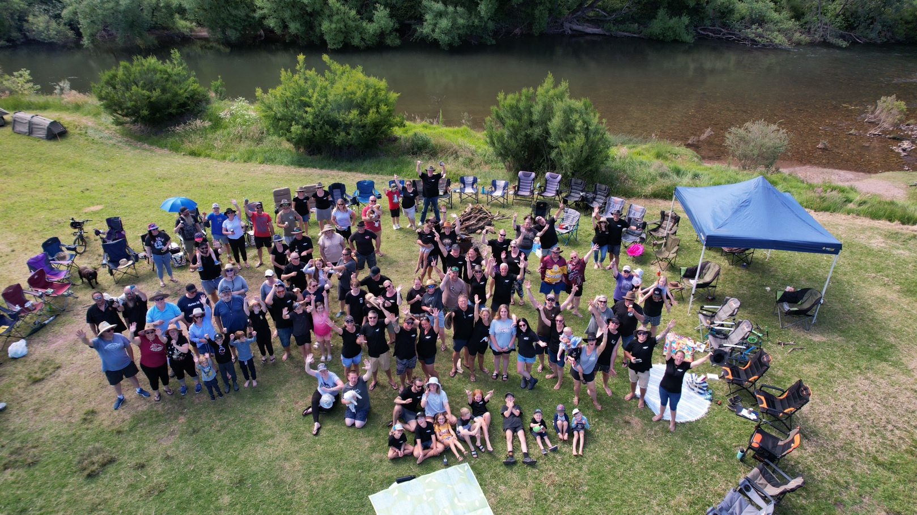

Hidden Valley Campground, VIC. 130 people attanded this event with approximately 60 caravans/campers.

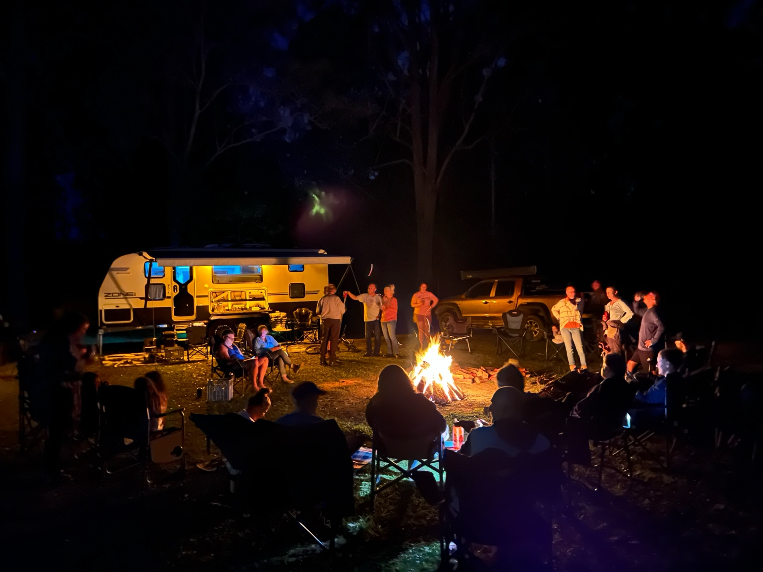

Coffs Harbour Camping, NSW. 88 people attanded this event with approximately 30 caravans.

## Conclusion

**Summary of Environmental Effects**

The proposed temporary event development approval at Agora Hideaway has been carefully designed to minimise environmental impact. With the mitigation measures outlined in this statement, the development is expected to have a negligible effect on the natural environment.

**Commitment to Compliance**

Agora Hideaway is committed to adhering to all relevant planning policies and environmental guidelines. We will work closely with local authorities to ensure the success of these events while preserving the natural beauty of the area.

# Agora Hideaway Flood Management Plan

## Objective

To ensure the safety of all event participants and staff at Agora Hideaway by establishing clear procedures for flood management or evacuation and emergency management.

## Site Description

**Location:** Agora Hideaway, Mole River, NSW

**Event Type:** Recreational camping (200 attendees, up to 100 caravans)

**Event Duration:** Once per quarter, primarily held on long weekends (Friday-Saturday) OR up to 6 caravans or 20 patrons (As per Agritourism Guidelines) on non-event dates.

## Pre-Arrival Communication

Campers will receive a *'Be Alert'* message via text and/or email prior to arrival, notifying them of any potential rain or weather changes that may increase the risk of flooding during their stay.

## On-Site Monitoring and Notifications

Once campers are on-site, real-time monitoring of local weather conditions and water levels will be conducted by Agora Hideaway staff. If water levels rise or there is an increased risk of flooding, campers will receive immediate notifications via text or email.

## Flood Risk Response

In the event of a potential flood risk, the riverside area will be closed off, and all campers will be promptly notified to evacuate the area. Campers and their equipment will be evacuated to higher ground before the risk becomes imminent, ensuring their safety.  
Agora Hideaway staff will utilise the onsite tractor to move any ‘at risk’ caravans or campers if flooding is imminent and the owners of the equipment are not available to move their equipment. All potential towing attachment types will be kept on site.

## Continuous Updates

Regular updates on weather conditions and safety measures will be communicated to campers throughout the event to keep them informed and prepared for any potential changes.

## Review and Update

This process ensures campers are well-informed and safe during their stay at Agora Hideaway. This plan will be reviewed prior to each event and updated as necessary.

# Agora Hideaway Bushfire Evacuation Plan

## Objective

To ensure the safety of all event participants and staff at Agora Hideaway by establishing clear procedures for bushfire evacuation and emergency management.

## Site Description

**Location:** Agora Hideaway, Mole River, NSW

**Event Type:** Recreational camping (200 attendees, up to 100 caravans)

**Event Duration:** Once per quarter, primarily held on long weekends (Friday-Saturday) OR up to 6 caravans or 20 patrons (As per Agritourism Guidelines) on non-event dates.

## Bushfire Risk Assessment

**Risk Level:** Agora Hideaway is in a rural, bushfire-prone area. The site is surrounded by vegetation and open spaces, making it vulnerable to bushfire risk. This plan is prepared with reference to the NSW Rural Fire Service's *Planning for Bush Fire Protection 2019*, which outlines necessary precautions for developments in bushfire-prone areas.

**Potential Hazards:** Grass fires, bushland fires, ember attacks and smoke.

## Emergency Contacts

**NSW Rural Fire Service (RFS) Emergency Contact:** 000

**Nearest Fire Stations:** Mingoola RFS, Sunnyside RFS, Tenterfield Fire Station

**On-site Emergency Coordinator:** Chris and Sian Crawford

**On-site First Aid Officer:** Sian Crawford

## Evacuation Triggers

Evacuation will be initiated under the following circumstances:

**RFS Bushfire Alerts:** Any bushfire warning or emergency level notice in the vicinity.

**Visible Bushfire Threat:** Smoke, flames, or embers approaching the property.

**RFS Direction:** Direct communication from RFS or emergency services advising evacuation.

## Evacuation Procedures

**Initial Alert:** If a bushfire warning is issued, all attendees will be notified immediately via loudspeaker.

**Emergency Signage:** Pre-installed signs will indicate evacuation routes and assembly points.

**Evacuation Coordinator:** The on-site Emergency Coordinator will oversee the evacuation process, ensuring everyone follows procedures and exits the campground. Evacuation routes and assembly points will be designated in accordance with recommendations from *Planning for Bush Fire Protection 2019* to ensure safe evacuation from the site.

## Evacuation Route

**Primary Exit Route:** From Agora Hideaway patrons will evacuate via the main entrance track to Mole River Road continuing onto the Bruxner Way. Mole River Road can be driven both East and West depending on a bushfire direction.

**Secondary Exit Route:** A secondary evacuation route is available from The Hideout campsite; in case the primary entrance track becomes inaccessible.

**Traffic Management**: Evacuation Coordinator will guide caravans and vehicles along the designated evacuation routes to prevent congestion.

## Evacuation Assembly Point:

**Location:** A designated safe zone at Mingoola Township OR Tenterfield Township, away from bushfire-prone areas and near emergency services.

**Check-in:** Attendees will check in with the Agora Hideaway staff upon arrival at the assembly point.

**Roll Call:** A roll call will be conducted to ensure all attendees have evacuated safely.

## Special Considerations:

**Vulnerable Persons:** Any individuals requiring assistance (elderly, disabled, children) will be prioritized during the evacuation. A staff member will be assigned to assist vulnerable persons.

**Caravans and Campers:** Attendees will be advised to leave caravans and non-essential items behind to facilitate quick evacuation.

## Communication Plan

**On-site Communication:** Two-way radios and mobile phones will be used by staff to maintain communication throughout the evacuation.

**External Communication:** The Emergency Coordinator will maintain direct communication with the RFS, providing updates and receiving evacuation instructions.

## First Aid and Medical Support

**First Aid Kit:** Carried by the on-site First Aid Officer.

**Medical Assistance:** If medical assistance is required, Triple Zero (000) will be contacted.

**Emergency Transport:** Agora Hideaway vehicles will be on standby to transport injured persons if required.

## Post-Evacuation Procedures

**Headcount:** A final headcount will be conducted at the assembly point to ensure all attendees are accounted for.

**RFS Communication:** Once it is safe to return, instructions will be provided by the RFS. No one will return to Agora Hideaway until official clearance is given.

**Site Assessment:** After evacuation, Agora Hideaway will be assessed for any damage or hazards before reopening.

## **Bushfire Safety Measures**

**Fire Breaks: Firebreaks have been established around the event site in accordance with the principles outlined in Planning for Bush Fire Protection 2019, ensuring that the spread of bushfires is limited and the safety of attendees is maximised.**

**Water Supply:** A portable water tank and firefighter water pump will be on-site to manage small fires, as recommended by *Planning for Bush Fire Protection 2019*, providing essential resources for an immediate response to fire outbreaks. Additionally, an irrigation system with supplementary tanks and water access points is being installed prior to the commencement of any events to enhance the land's fire management capabilities for both event and domestic use. For imagery of the proposed irrigation system, please refer to Appendix A.

**Emergency Shelter: A designated shelter area will be identified in case evacuation is not immediately possible, ensuring the safety of all attendees during emergencies.**

**Site Monitoring: Regular weather and fire condition checks will be conducted before and during events using the RFS website and other official sources. Events will be cancelled if the risk of fire is deemed too great, aligning with fire safety protocols outlined in Planning for Bush Fire Protection 2019.**

## Review and Update

This evacuation plan will be reviewed prior to each event and updated as necessary in consultation with the RFS.

## Appendix A

